Chicken – Kale – Sweet Potato
Why this recipe works:
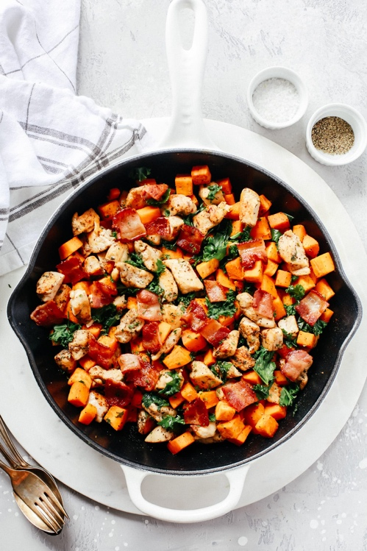
This recipe is great for a quick light dinner or lunch. It holds well as a dish to enjoy throughout the week. We have seen kale be chewy or overcooked. In this recipe we “massage” the kale with a slightly acidic/flavorful vinaigrette which softens the kale but still keeps it crunchy. The chicken can be substituted with Italian sausage. Have fun and add, nuts, cranberries, apples, whatever you may have in the pantry to give this dish textures.

Ingredients:
1 lb | Chicken Breast diced of Italian Sausage
2 Tablespoon | Italian Seasoning (check if salt is in ingredients)
2 Teaspoon | Salt
1 Teaspoon | Pepper
2 Tablespoon | Olive Oil
2-3 | Sweet Potatoes (diced)
2 Teaspoon | Salt
1 Teaspoon | Pepper
2 Teaspoon | Garlic Powder
2 Teaspoon | Onion Powder
1 Tablespoon | Olive Oil
½ lb | Kale (pre-prepared, stems removed)
 | Home-made Apple Cider Vinaigrette (Place all ingredients in a small bowl or jar, whisk until smooth about 30 sec – 1 min) Or use a jarred vinaigrette of your choice)
1 clove | Garlic Minced
1/3 cup | Extra-Virgin Olive Oil
1/4 cup | Apple Cider Vinegar
2 Teaspoon | Dijon Mustard
½ Teaspoon | Salt
¼ Teaspoon | Ground Pepper

Directions:
- Make apple cider vinaigrette. Pour over kale and work into the greens, set aside in fridge
- Dice sweet potato and season. Hold off to the side.
- Dice chicken breast and season. Heat a skillet pan to medium-high heat until shimmering.
- Add chicken to heated pan and let cook for 2-3 minutes per side or until browned.
- Place chicken on a plate and set to the side. Wipe pan and add 1 Tablespoon olive oil.
- Bring pan back to heat. Add seasoned sweet potato and cook until soft, stirring every few minutes, until browned and fork tender about 10- 12 minutes.
- Place Kale into a bowl, top with cooked chicken and sweet potato.
- Enjoy!

